

**PHWB JOINT MEETING 1**

**SUMMARY REPORT**

**Project number: 2015-1-UK01-KA201-013732**

30th Jan to 4th Feb 2015



***O***riginally planned for November, the first joint meeting of the 2015 KA2 Pupil Health & Well-Being project took place in the capital of Gran Canaria, Las Palmas, at the end of January and start of February in 2016.

This was the first chance for all of the partners from the UK, Greece e and Spain to be able to travel and meet and work together, as not all categories of project funding in the application were initially approved and appealing the funding decision took time. Further weeks passed waiting for the first instalment of grant to arrive from the National Agency and by then, Christmas holidays meant a further wait. It is fair to say that all partners were energized by the delay, however, and ‘ready to get the show on the road!’

**Saturday, 30th Jan.** 6 Greek and 10 UK partners travelled to the island of Gran Canaria, ES --off the coast of the Western Sahara-- for the meeting. All booked into the Hotel Aloe Canteras in the capital city, Las Palmas and prepared for the activities of the following day.

**Sunday, 31st Jan**. At 9am, the leaders of the Spanish team met the visitors at the hotel and all walked to Playa de Las Canteras beach, 50 metres away, to begin 2 hours of team building. A very successful session of getting to know and trust each other resulted, as each country in turn led a 40 minute activity. These included memorizing names and facts about the other teams, throwing and catching eggs with partners and designing and building structures in the sand together.

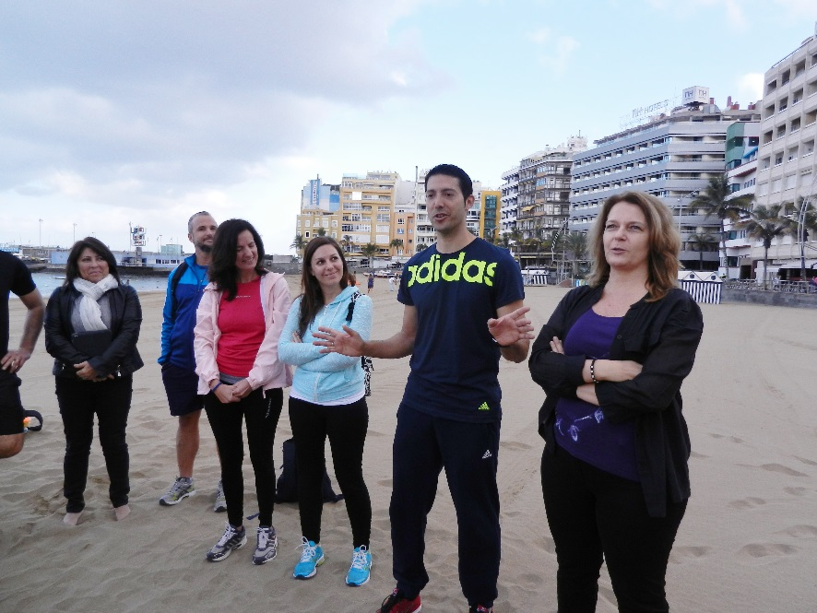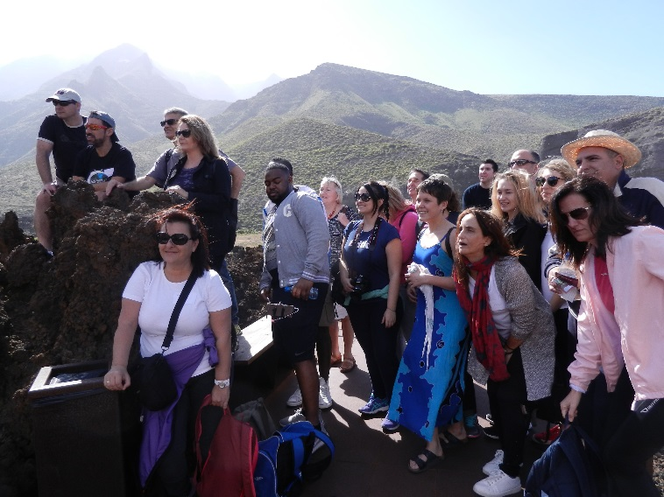

A quick change and the group then left by guided coach to learn more about the island and to tour Agaete in the north-western island and the natural and architectural sites there.

Lunch by the sea at a popular local restaurant followed with more opportunities for discussion before a short trek along the coastal cliffs and the teams went their separate ways for the day, with some able to go with some of the hosts to watch the local football team win a top level match at the island stadium.

It had been an excellent start to the first joint project meeting and hosted with care.

**Monday, 1st Feb**. After breakfast, a coach took the visiting project partners to meet their Spanish colleagues at Las Palmas University, the venue for the day’s work.

The meeting began on time with a sincere welcome from the University Dean, Marino Alduan.

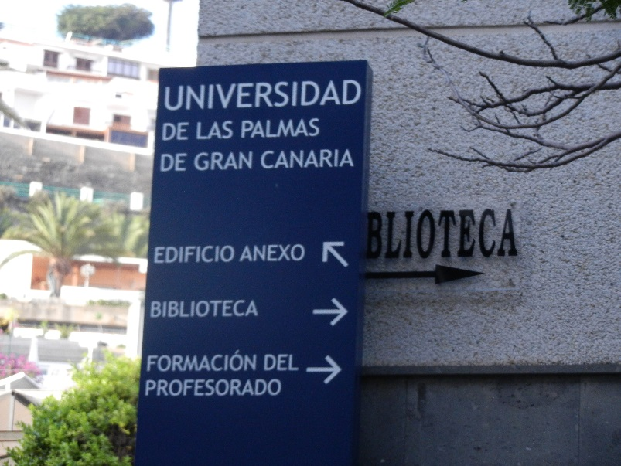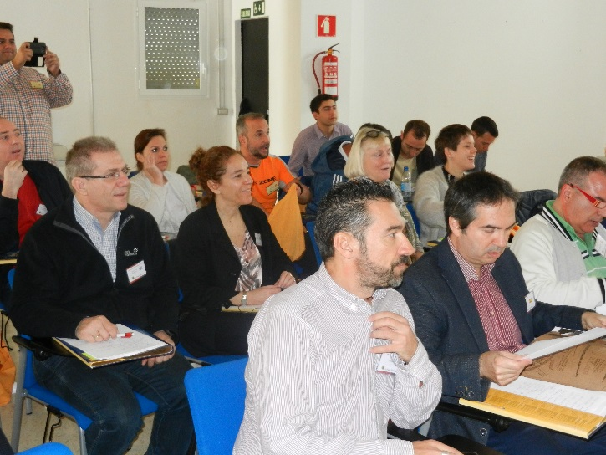

The Spanish team and the UK project coordinator, Chris S, then offered their introductions and asked the teams from each country to again introduce all partners. Evelyn H of John Donne Academy then delivered the agenda for the day before her teacher, Alana R, led a ‘Post It Note Task’ with all those present. Each participant was asked to write down 3 objectives/ expectations for the meeting and these were then stuck on the wall, discussed, and recorded to be returned to on the final day.

Because it was the first time all project partners had been together formally, the coordinator then made a presentation to outline the full history of the project. He spoke of the parameters of the Erasmus+ program and of the 2 self-funded prep visits which had been undertaken to design the work.

The vision of the project is a ‘whole school, whole child’ approach by every school to the physical and emotional well-being of every child--and helping to promote this through teacher training across Europe. One of the initial planning meetings in January 2015 had been held in Greece and so he then handed over to Vassilis B of Aristotle University who outlined the project’s work plan and schedule of objectives.

Chris then introduced the project web site ([www.PHWB-project.com](http://www.PHWB-project.com)) before discussing the project finances and accounting and stressing the importance over the 2 year of the approved Application Form, which will remain the project ‘Bible ‘for the life of the project.

After questions from the floor, the group then had coffee and healthy snacks in the courtyard downstairs before returning at 11.30am to hear from all partners about their progress in their own institutions around the Health & Well-Being theme of the project.

Every partner institution in the project presented an excellent power point presentation, outlining their progress. (See these at project web page: <http://phwb-project.com/?page_id=791>) *--The exception were the 2 Spanish project partner schools, who have attended many local meetings and were an enthusiastic team at this meeting, but who did not feel ready yet to make such a formal presentation.*

Without exception, these presentations were impressive and varied. Great activities have begun, from the formal writing of plans for the project teacher training outcomes by the Universities to collaborations between the gyms in the project with their local partner schools and pupils and reviews of food and PE delivery in some schools. If these activities can be undertaken so successfully before the partnership of 10 had even formally met for the first time, hopes must now be high for what can be achieved before the project is completed in 2017.

At 1pm, a very upbeat partnership left to walk 5 minutes to a local Italian restaurant for lunch. This was good, but slow service meant a later than expected start back at the University for the afternoon session.

The coordinator quickly cut back the time scheduled for each of the afternoon activities in order that all the work could be attempted. First, 60 minute (rather than 90 minute) ‘sector’ discussions were held. These allowed those writing our training module project outcomes (predominantly from the 3 Universities in the partnership) to present and compare and critique all of the module plans from all of the countries Meanwhile, the school and gym partners further energetically discussed their institutions and practice and searched for areas of common approaches/ concerns.

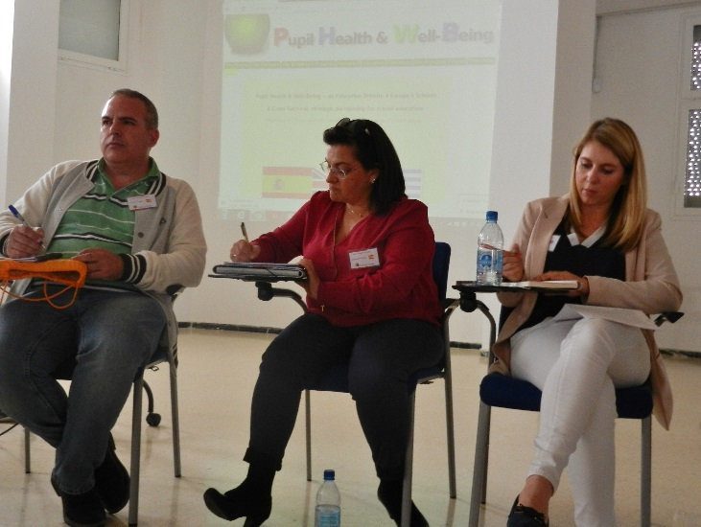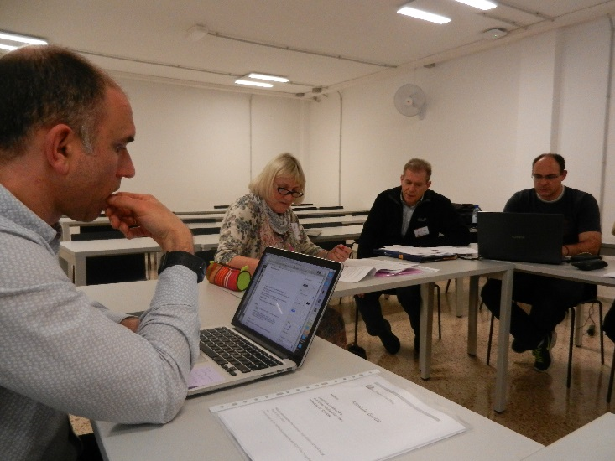

After that, 40 minutes of work in National groupings occurred. In separate groups, the UK, Spanish and Greek teams shared the modules development so far and discussed how the activities being undertaken for the project in schools & gyms might feed into the Training Module Outcomes.

Research data should be able to be collected from well-designed activities planned in schools that relate to our project theme. This should integrate the different sectors into our project and our outcomes. Slightly over time, the meeting adjourned with a sense of work well done and more to be achieved the following day.

**Tuesday, 2nd Feb.**  The day began with the delegates returning by coach to the central Las Palmas University campus in order to take part in a dissemination event which the Spanish team had organised for 9am.

The Head of the University, along with a panel consisting of project leaders from each country (Evelyn H, John Donne Academy, UK/ Vassilis B, Aristotle University, GR and Toni A, Las Palmas University ES) addressed the meeting with local press and television in attendance.

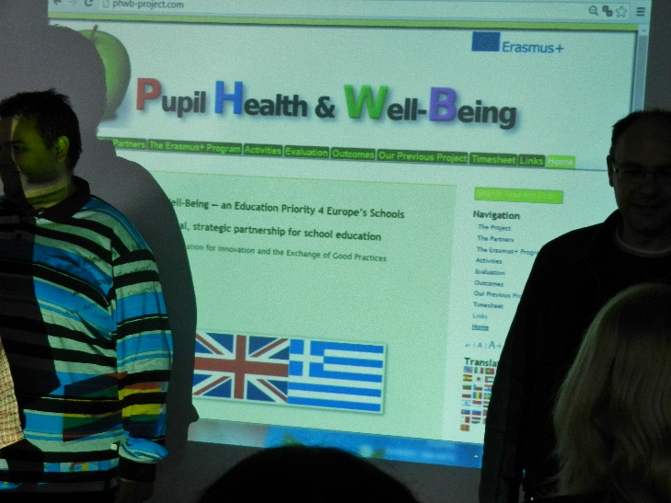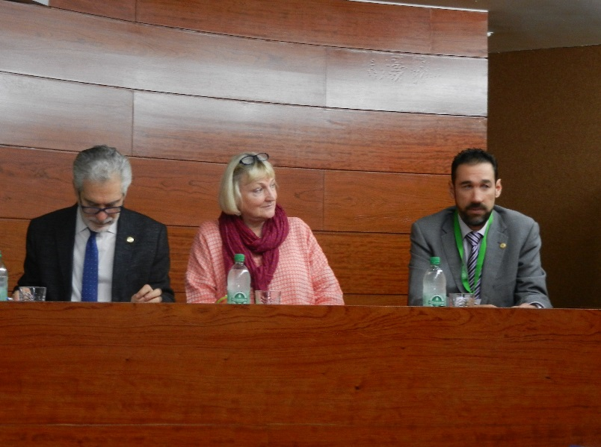

This proved an excellent idea, with the project reported next day in the papers and television interviews made later with the panel aired on local TV. <http://www.canarias7.es/articulo.cfm?id=406487>

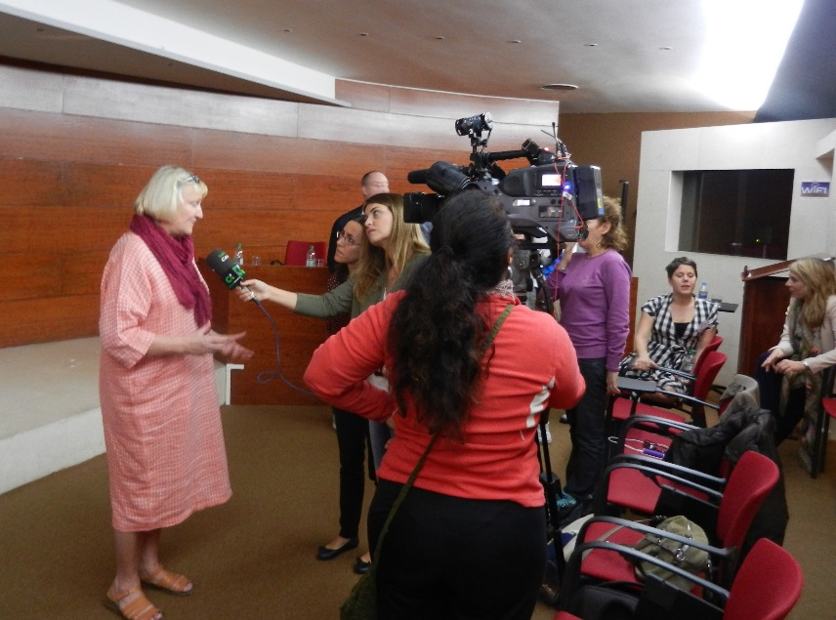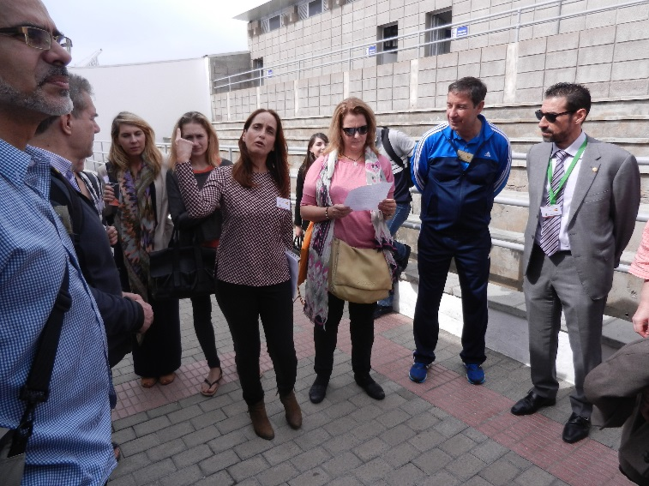

Once completed, all partners spent the next hour reporting back on the discussion group work from the previous day. This was a valuable chance to share information and views again. In the sector groups, the Universities (and those from schools also authoring training) could report agreement on the plans presented and a belief that they will all work well together. The School and Gyms group had discussed many issues of health and emotional well-being and the possibilities for future E-Twinning collaboration around various pieces of curriculum work they deliver. The National groups had discussed both the trialling of our module outcomes in their schools as well as how the data they were collecting from their own activities might be incorporated into the training modules.

Those not involved in the writing of the module outcomes then left for coffee and networking outside in the open air, while the outcome authors had further discussions about the formatting of the modules and ensuring the continuity of all 6.

Delegates were then driven to project partner school, Claret School, where leader, Patricia Morales, gathered them to tour the school and see the physical learning taking place. The school has an impressive swimming program held in their own pool, as well as full scale running track (complete with artificial beach for the teaching of beach sports) and a gymnasium for gymnastics, all of which were being well used.

John Donne Academy, UK, is particularly proud of its catering which is part of its drive to ensure the well-being of both staff and pupils….and their Catering Manager attended the meeting to highlight the importance of this aspect of well-being. He was now able to spend time in the large school kitchen, sharing practice and meal plans with the team there, before everyone then ate lunch in the school canteen.

Lunch completed, it was then time to head into the meeting room for the last of the more formal working sessions.

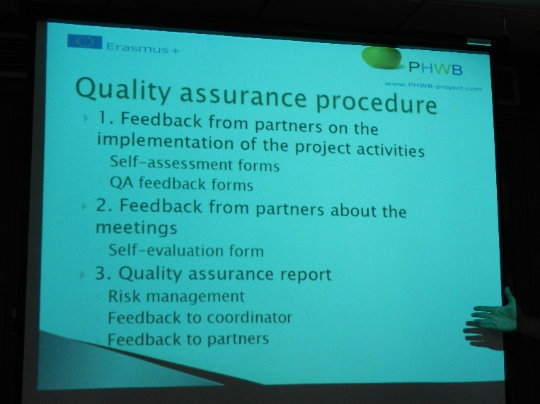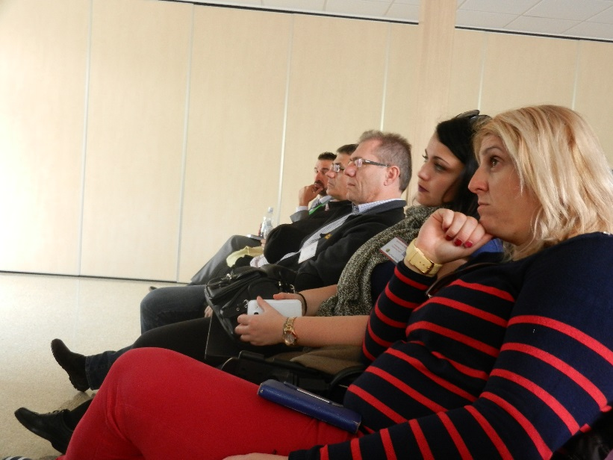

The coordinator began by asking several of the group to expand on a conversation they had been having about the positive pupil behaviours that they had been observing at Claret School during the lunch time session. The well-being of pupils is directly affected by the behaviour of other students and vice versa, so this was a way to integrate the setting for the meeting into the formal session as well as to gently lead the meeting back to more serious discussion.

Local teacher, Cecilia Cantizoni, then arrived to share her experience of ETwinning with the meeting and especially the schools present from the 3 partner countries. It is part of our application objectives that schools collaborate using this EU platform and all partners were left clear how to register and invite the others to ‘meet’ there and began to discuss the sharing of data and activities around 3 specific themes related to Health & Well-being… physical health, mental health and nutritional health.

In order to meet the project management and dissemination objectives as laid out in the application, each country then led on discussing a specific theme they’ve been allotted, relating to project management.

Vassilis B (Greece) began by setting out his understanding of project Evaluation and our plans for quality assurance. Ray Kirtley of University of Hull and Global Learning Association will also provide some External Evaluation for the project, though as this was not funded from our bid, this will be more limited than initially imagined and this was discussed.

Daniele C (Spain) then made a presentation about Dissemination. This has already begun….but an action plan was laid out for all, including the need for them to compile a list of stakeholders and press releases to be sent out ASAP. Universities were made aware of the need for them to have begun or even completed other important aspects of dissemination by the next meeting in the UK where they will need to report on them. (--such as the writing of Journal Articles and the holding of events for schools outside of the partnership).

Evelyn H (UK) then discussed Communication with the group. She stressed the points made by Vassilis in his presentation about how important it is to respect deadlines and to reply to all emails received quickly. She also collected phone numbers so that a phone group for alerts can be established across the partnership and encouraged the use of drop box for documents.

With 30 minutes remaining of our scheduled meeting, there was just time to again welcome Alana R (John Donne Academy) back to review the expectations exercise from the first day and to ask if everyone’s meeting expectations had been met before the important business of setting dates for the next meetings. These were discussed and added to diaries: -- **Joint Meeting 2, JUNE 27TH--JULY 1ST, 2016 London, UK**

**Joint Meeting 3, NOV 6TH--NOV 10TH, 2016 Thessaloniki, GR**

He again mentioned that Meeting 2 will allow some external evaluation as Ray Kirtley will be able to attend the meeting without incurring the costs of international travel. The coordinator also suggested inviting the British Council to the London meeting to undertake a monitoring visit.

Evaluation surveys covering the content and practical arrangements for Meeting 1 were then handed out and the meeting ended as these were collected and the participants retired for coffee and final words.

**Wednesday, 3rd Feb.** 9.30am Greek University delegates headed off to the University of Las Palmas Tafira campus where the Physical Education Campus Is located (along with Engineering etc.) There, they were met by Toni A, Dr Miguel Betancour and Ulysses C, director of the gym who showed them around the impressive teaching facilities.

10.15am Meanwhile, the UK delegation had been checking out and soon departed by mini bus to fly home from the airport.

The coordinator saw them off before packing then reconvening with the 6 Greek delegates at 11.30am. In 2 hire cars, they set off for the south of the island, with the chance to discuss together the developments during the meeting. This proved to be a fertile day of strengthening relationships, first at the dunes of Maspalomas and later on the drive to Porto Rico and Porto Mogan where they ate, before heading back to Las Palmas around nightfall. All agreed the project meeting had significantly strengthened the project and had gone even better than hoped.

**Thursday, 4th Feb.** The coordinator met Jesus A at the central University campus at 9am. Together, they set off to drive to the Physical Education Department on the University’s Tafira site.

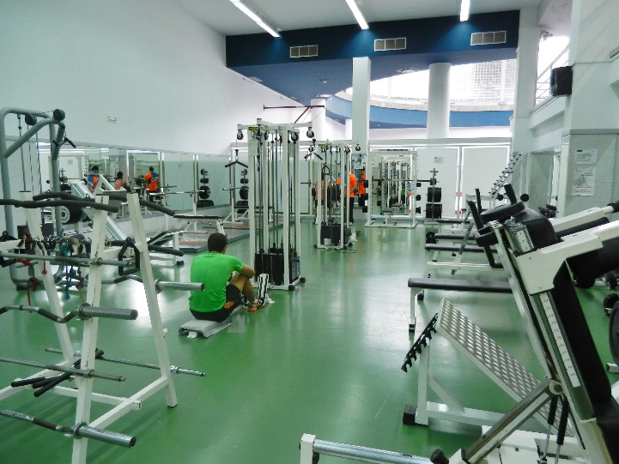

Over the next 2 hours they toured the facility with Ulises C and discussed additional project activities that might take place, including job shadowing between the 3 University gyms involved in the project.

They also discussed the venues which might be used for Meeting 4 at the end of the project back in Gran Canaria and visited the PE library, and the restaurant to see where meals might be served as well as several classrooms.

The Coordinator then returned to the central University campus to meet with Daniela C (ES) and again evaluate the tasks to be done before our next meeting in London. These were discussed during the formal sessions of the joint meeting, but will again be sent out to all partners by email once all have returned from what was a very successful and very positive first Joint Meeting in Gran Canaria.

#

**TO ACTION AFTER MEETING 1**

**ALL—**

*SAVE NEXT JOINT MEETING DATES TO DIARY:*

**Joint Meeting 2, JUNE 27TH TO JULY 1ST, 2016 London, UK**

**Joint Meeting 3, NOV 6TH TO NOV 10TH, 2016 Thessaloniki, GR**

PREPARE AND SEND OUT AT LEAST ONE PRESS RELEASE *(Notify Coordinator and Daniela C)*

FOR DANIELA (ES) – COMPILE LIST OF STAKEHOLDERS FOR DISSEMINATION BY 29TH FEB

WRITE (FINISH) ALL 6 OUTCOME MODULES TO THE PLANS AGREED AT MEETING 1

REGISTER FOR ETWINNING AND SHARE IDs WITH PARTNERS ONCE NATIONAL AGENCIES IN EACH COUNTRY REGISTER YOU

UNIVERSITIES AND GYMS AND SCHOOLS – COLLABORATE AS DISCUSSSED AT MEETING 1 TO EITHER TRIAL MODULE CONTENT OR PROVIDE ACTIVITY DATA TO INFORM MODULES

**UN IVERSITIES**

GREECE – TO UPDATE BASELINE SURVEY TO CAPTURE MORE DATA & CIRCULATE [http://goo.gl/forms/c6D85mtU5k](https://3c-bs.gmx.com/mail/client/dereferrer?redirectUrl=http%3A%2F%2Fgoo.gl%2Fforms%2Fc6D85mtU5k)

DISSEMINATION EVENTS – EACH UNIVERSITY TO EITHER HOLD – OR PLAN WITH DATES TO REPORT AT MEETING 2 – DISSEMINATION EVENTS FOR SCHOOLS (EITHER AS STAND ALONE DAYS…OR BY INVITING IN SCHOOLS OUTSIDE THE PROJECT )TO BE ‘TRAINED’ WHILE TRIALING ANY OF THE PROJECT MODULES WITH THEIR TRAINEE TEACHERS

PLAN (AND WRITE) JOURNAL ARTICLES (e.g. 1 CONCEPTUAL AND 1 DATA LED EACH) AND DECIDE WHICH CONFERENCE/S TO ATTEND

*E.G. European Journal of Physical Education (quite high brow) OR publications of the subject associations in each country or*[*ICSPE*](https://3c-bs.gmx.com/mail/client/dereferrer?redirectUrl=https%3A%2F%2Fwww.icsspe.org%2F)

SIGN OFF THE 2 MODULES PER COUNTRY, READY TO UPLOAD BY JUNE & PRESENT AT MEETING 2

**SCHOOLS/ GYMS**

CONTINUE TO DEVELOP ACTIVITIE S AROUND A WHOLE SCHOOL APPROACH TO HEALTH & WELL BEING WITH STAFF AND SCHOOL PUPILS.

PREPARE TO REPORT ON THESE AT MEETING 2

SHARE PRACTICE (ROUND THE 3 THEMES IDENTIFIED?) ON ETWINNING

TRY TO COLLABORATE ON THEM WITH THE UNIVERSITY GYMS IN THE PARTNERSHIP IF POSSIBLE

TRY TO ADD VALUE BY SHARING/ COLLABORATING ON THEM WITH PARTNERS ABROAD. E.G. CONTINUE TO SHARE SCHOOL MEAL PLANS WITH OTHER SCHOOL’S KITCHENS ETC

CONSIDER ADDITIONAL ACTIVITIES: eg. Job Shadow placements between project partners (Catering staff? Gym trainers? Teachers?)

LOGO PIC COMPETITION (CS TO PRINT UP POSTCARDS WITH THE WINNER BY NEXT MEETING)

**IDEAS FOR MEETING 2 PROGRAM (July, UK)**

STAY LORING HALL/ LSBU STUDENT ACCOM?

MEETINGS EVERY MORNING & ACTIVITIES AFTERNOONS?

-RECAP MEETING 1

UPDATE OF MONEY PAID/ FINANCES

AUTHORS—TIME TO WRITE AND FINALIZE MODULES TOGETHER

(While…) SCHOOL GROUPS VISIT AND SPEND TIME (WATCHING SPORTS INSTRUCTION ETC) AT John Donne and Alfred Salter Schools.

ALL MODULES PRESENTED

PRESENTATIONS FROM THE ES PARTNER SCHOOLS WHO DID NOT PRESENT AT MEETING 1

10 MIN PRESENTATIONS AS PER MEETING 1 FROM EVERY PARTNER: WHAT HAVE WE DONE SINCE THE LAST MEETING?

VISIT TO CLUB PULSE AND WORK OUT AS IF WE ARE THE 11 YEAR OLD THEY HAVE BEEN TRAINING.

COOK A MEAL TOGETHER WITH JD STAFF?

3 COURSE MEAL AT JD FROM THE SCHOOL KITCHEN?

ETWINNING UPDATE

DISSEMINATION--LIST OF STAKEHOLDERS REVIEWED/ DISSEMINATION EVENTS AT UNIS REPORTED ON/

EVALUATION UPDATE—VASSILIS/ RAY KIRTLEY WORK/ ALL FILL OUT EVAL QUESTIONAIRRES ON COMPS AT JD SCHOOL.

PLANNING FOR MEETING 3 AND TRANSLATION OF OUTCOMES

GREENWICH PARK TRIP/ TAYYABS MEAL. LEBANESE/ TURKISH MEAL

**IDEAS FOR MEETING 4 IN SPAIN (2017)**

HOLD AT TAFIRA UNIVERSITY CAMPUS & CEP?

WATCH ‘TECHNIQUES OF PE DELIVERY’ (MODULE 2) AT TAFIRA SPORT HALL?

VISIT MARQUEPENA SCHOOL?

DISPLAY OF TRADITIONAL GRAN CANARIA SPORTS (Ask ULISES CASTRO TO ARRANGE) GC WRESTLING/ POST CARRYING/ RACQUET BALL ETC?

TRAINING EVENT – HOLD AT CEP? (ACCREDITATION BY ALL 3 UNIS)

**TO DO:**

COLLECT ALL MEETING 1 PRESENTATIONS

INVITE OWAIN AND BETH TO MONITOR MEETING 2

UPLOAD ALL LOGOS