

**PHWB JOINT MEETING 4**

**SUMMARY REPORT**

**Project number: 2015-1-UK01-KA201-013732**

Las Palmas 14 – 19 June 2017

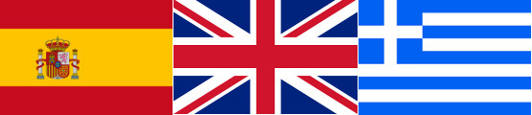

The Spanish team, led by the Universidad de Las Palmas de Gran Canaria, again hosted the final join meeting of our 2 year collaborative project in June, 2017. The objectives this time included to evaluate and use the training module material developed during the last 2 years, to lead a training activity with educators not familiar with the project until now and to finalize plans for the last project activities that conclude after this meeting.

**Wed 14th June, 2017**

Participants from the partner organisations travelled to Las Palmas, arriving in the late afternoon and evening.

**Thurs 15th June, 2017**

The Greek and UK meeting participants were met at the University Residencia, San Telmo, their centrally located sleeping accommodation for the period of the meeting.

Setting off on foot, the large group made their way to the nearby underground bus station, then off by bus to Marpequeña School (Telde). This was the first time that the partnership had visited this school all together and the school taff and pupils had made a wonderful effort to welcome our group. Flags of the project participating nations and of the EU adorned the grounds. Welcome fruit drinks were served. Colleagues were reacquainted…..and then the formal welcome celebrations commenced—speeches, songs and sporting demonstrations enjoyed by all.

Inside, the project coordinator reminded everyone of the considerable progress on the work of the project since its inception. All work plan activities have been undertaken (or will be completed in the weeks to come) and the partnership can feel rightly proud of their achievements. All teams updated the meeting on their personnel and the preparations they had made leading up to this meeting. Marpequeña School staff presented a PowerPoint about their school.

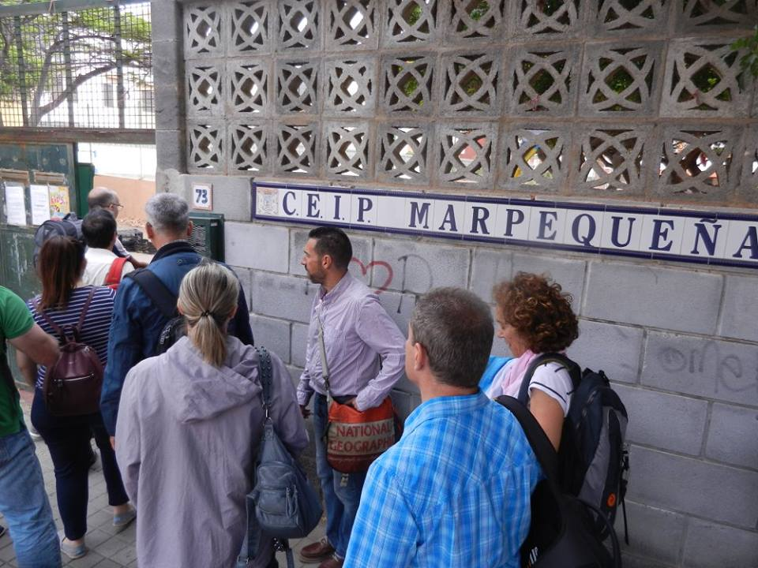 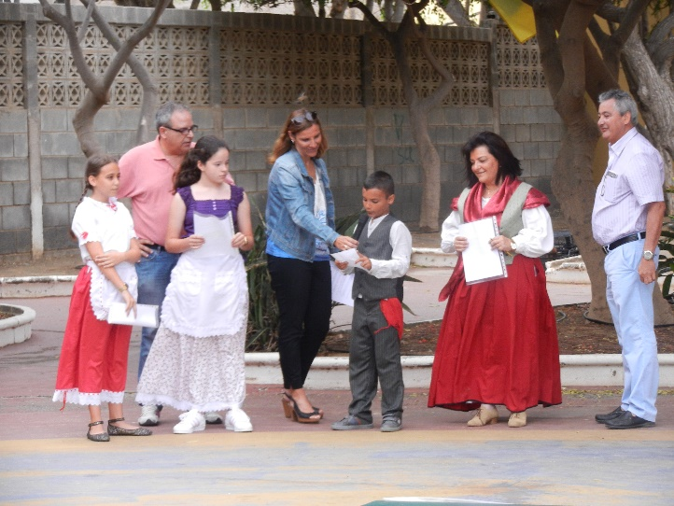

Jesús Alemán from the University of Las Palmas presented a short film displaying the diversity of the various Canary Islands…then the group broke up to work further on preparations for the PHWB training event, which is one focus of this meeting. Those new to the project began their first Training Event session (led by the project coordinator who outlined for them the role of the EU and its education programs.) All were encouraged to consider possible future activities they might engage with in their own institutions and how international links and projects might be supported.

Meanwhile, those who would be delivering the PHWB modules to the trainees in subsequent sessions worked in national groups on finalizing their content and supporting materials.

Once all had reported back, at 13.30, it was time for a wonderful lunch rich in Canarian dishes.

At 15'00: a coach arrived to take the party to the University of Las Palmas Faculty of Sciences of Education (FSE)

Preparations were quickly made for the established members of the project to Skype with Birmingham, UK at 15'30 while the ‘trainees’ attending the meeting were sent to explore the history of the Las Palmas old town with a guide. The Skype facilities worked well and allowed teams from all 3 countries to present and disseminate the project and its outcomes to a UK wide group of international education advisers gathered in Birmingham for the annual Global Learning Association conference. 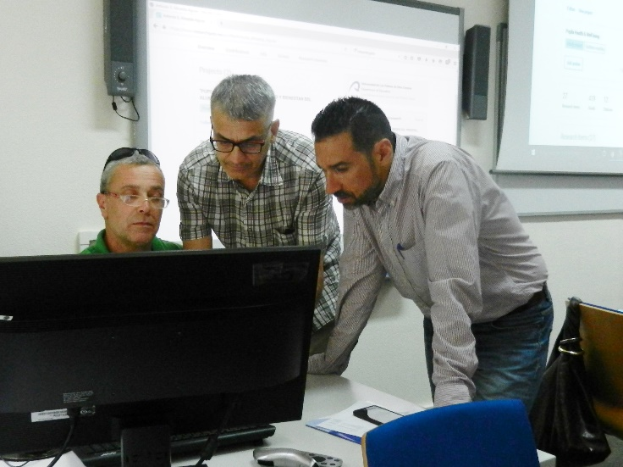 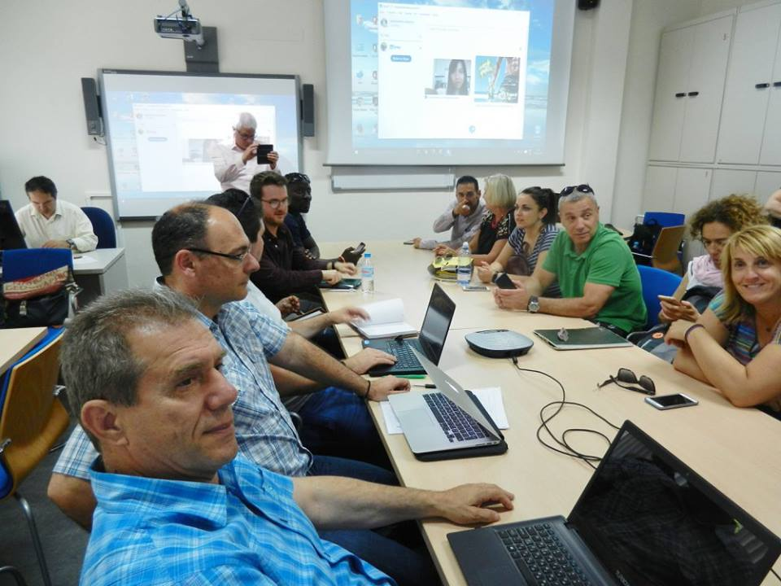

Once this was completed, at16'30, all teams began again discussing their module segments to be delivered as training during this meeting. A more developed final draft for the ‘course’ was then compiled and discussed. (This is based on the one week PHWB course formulated together at Joint Meeting 3 in Greece, but compressed.) All were of the opinion that it would be informative, inclusive and varied in its presentation styles.

Here (Annex 1) is the Plan finalized that day:

**Annex 1**

Final Agenda for the Modules based part of the Training Event.

MODULE 1   **Pupil health and Well-Being - the whole child**

15 mins Introduction (Coordinator) / Self-reflection on how each of us found our own school experience of PE & pastoral care to be/ discussion in pairs on how staff in a new school might set the agenda for a whole school approach to pupil health & happiness (PHWB School GUIDELINES to be distributed)

Discussion (Evelyn)  ...  what does Health & Well-Being mean to different people-

a sense of meaning and purpose etc. etc.

What does that look like in your own life? e.g. connecting with people. Being active. Lifelong learning.  Give of our time and emotions to others.

Task – reflecting on well-being.  Group discussions.

Self-review activity on our personal resilience.

Attachment theory training...by Evelyn

In the room game...what is it like to work in a team, to struggle, to communicate together etc.

*All to complete evaluation survey*

MODULE 3 **Developing a Positive & Inclusive Learning Climate for Fitness**

A Practical then a theoretical focus.

PracticalÑ   5 mins Chrysa diff teaching styles.

15 mins Agriious demonstration for participants

Christa

Apostolia 1o mins for an activity within a curriculum subject.

10 mins video ....how have these styles been implemented in the schools

25 mins presentation

VB....how we promote autonomous support in our classrooms.

10 mins theory ...what its all based on.

*All to complete evaluation survey*

MODULE 6 **Gender & Disability & Cultural Issues affecting Physical Education**

3 sections  1- theory about traditional games and general aims 10 mins – led by Antonio (teacher at the secondary school), Ulysses and Toni A

2   Practical 30 min session on traditional games.

3.   Antonio and Havier (prof in performance)   30 mins practical session on dance

20 mins eval and feedback.

some Olympics (Sports Day) input

*All to complete evaluation survey*

MODULE 2 **Teaching for Learning Styles in PE**

Objectives of the module

20 mins Inc. discussion on purpose of PE, in small groups

30 mins activity in hall/ using sports facilities etc.

David and Dean (Club Pulse) ...extrinsic and intrinsic learning  starting with activities first demonstrated and then carried out by participants and then group discussion.

Discussion at end led by Andrew and Matt   --feedback

Theory behind it .

Vision moving forward...self-reflection activity and then sharing.

*All to complete evaluation survey*

MODULE 4 **Behaviour Change for Healthier Lives**

THEORETICAL

15 mins Vasilis   theories of behavioural change  -presentation

30 min Vas P...life skills development presentation

PRACTICAL

Vas P    45 mins  games for the prep phase- games for the main phase- then for final phase of  a lesson...on how to improve life skills.

*All to complete evaluation survey*

MODULE 5 **Using Local Environments & Community Involvement to Promote Health**

JESUS & team will explain in 25 mins connection between environment and health.   Presentation format then practical activity...on food 20 mins a game with food able to be used in schools.

Environmental activitiesÑ presentionÑ Mary Carmen and Juan carlos

Walk --participants take photos.....photo contest.

Judge the photos then we look at a sport activity eg. stick game....all participants take part.

*All to complete evaluation survey*

Plans agreed, the full group of participants from Spain, Greece and the UK reconvened for the 18'30 start of the next programmed event in the main auditorium. There were good memories of this room, as it was here that the press call had been held at the first Joint Project Meeting almost 2 year before.

Vice Rector Speech: Dr. Richard Clouet addressed the group as did the UK project coordinator and the lead partners from the University of Las Palmas and Aristotle University. All thanked the others for their excellent engagement with the project. All then posed following the speeches for photographs with A.Judith Gutiérrez Negrín, Responsable de la Oficina de Programas Europeos de Canarias. There was then a chance to freshen up before Dinner in La CABAÑA CRIOLLA Restaurant. Playa de las Canteras at 20'30.

**Friday 16th June, 2017**

This day saw our training event activities focus on delivering activities for our trainees, based on the PHWB Module outcomes that the partnership developed during the previous 2 years. We made our way to secondary school (and project Partner) Claret for this day’s training where we received a warm welcome and red ‘Claret School’ shirts were handed out to everyone. We went through to the school hall and began to set up.

We started 20 mins late due to room set up and technical problems, but once rolling, the day unfolded as planned. The UK project coordinator focused on those present from all 3 countries who so far were ‘new’ to the PHWB project and welcomed all those present to the training.

He began by summarizing why everyone was present, what the project has focused on developing and how the next few days would be a stripped down version of the 1 week course we’ve developed based on our 6 module outcomes.

He then got them to reflect on their own experience of PE / sport etc. as a child. Was it good / bad? Empowering/ damaging? Then he asked them to think about what experience of the same that their schools offer currently to their pupils.

He then got them to discuss in pairs what they might need to do if they were starting at a new school and wanted to promote a whole school/ whole child culture of health and well-being.

Evelyn H from John Donne Academy then began the formal presentation based on the chosen parts of Module 1. She set the scene by asking the questions, “What do we mean when we think of fitness/ well-being?” And, “What do we need to have these things in our lives?”

She then examined how science says we can be adversely affected without these things. E.g. junk food adversely affects brain chemistry.

Then…..the wheel of wellbeing task was undertaken. Participants then did a ‘grit scale’ task … a personal fortitude type survey.

Evelyn talked about resilience and encouraging pupils at school to be resilient. This can be the greatest gift a teachers gives to a pupil.

Attachment theory was discussed next. She talked of emotional stability. This begins at birth and is essential for brain development. She showed images of a normal 3 year old brain and one starved of affection and nurture. The pictures were striking. Damage caused by a lack of support and affection in the early years is permanent. This is the sobering reality.

11.10 am. Evelyn and the John Donne and Alfred Salter teams then led a 20 min long group task. The ‘Paste and paper inside game’ was to model for them how they with pupils, they can encourage team work/ good relationships/ having a sense of achievement/ focusing on detail….

The simulation game involved them Imagine you’re in a village in India, making paper bags to selling order to pay for shelter, food, medicine, clothing

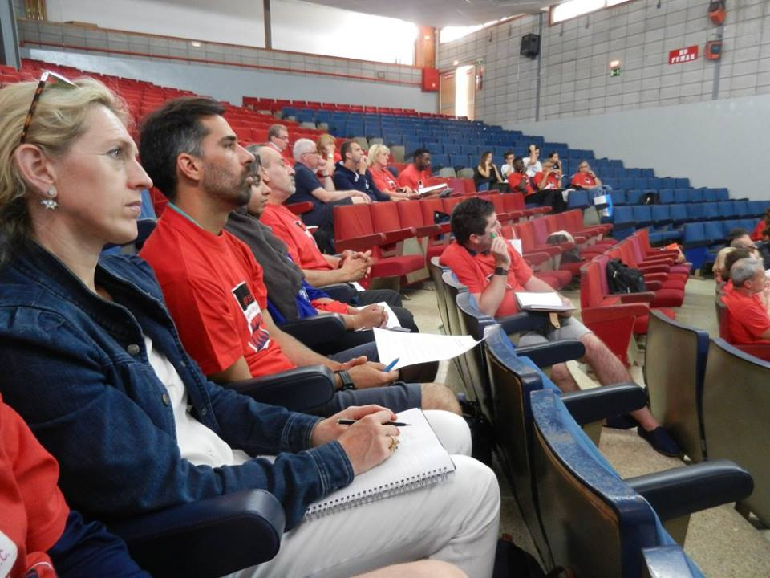 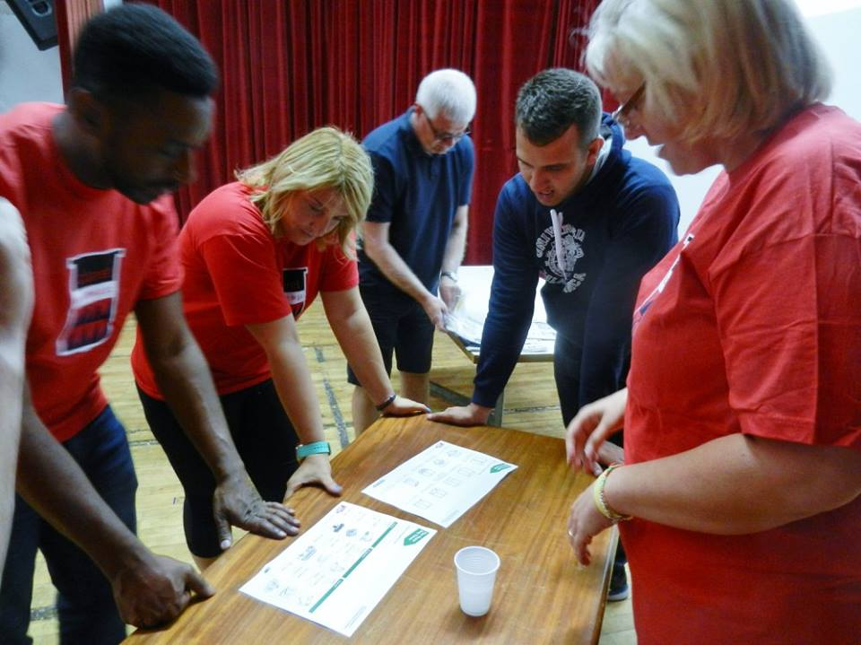

This went very well with all taking part very energetic and engaged with their groups and all very competitive.

Then they had to extrapolate how many they could make in a week with 10 hour days and therefore how much money they would earn.

Discussion of the task followed. Evelyn asked how they felt to be engaged in the team. Dean (Club Pulse) …stressful/ others exciting/ guilty as I was not good at it/ hard to get into a flow. Natasha’s group created a construction line with one who knew how to do it teaching the others. (Flow Theory is outline more in the Module 1, she said.)

We then examined what everyone needs for well-being and mental stability.

“Something to do/ someone to love/ something to look forward to….basic human needs.”

After a good session it was time for evaluation sheets to be distributed and then for a coffee break.

12.25 New LSBU participant Sarah J-S was formally introduces before Vassilis B (Aristotle University) set out what would be covered from MODULE 3

He described how some of the theory would be modelled outside on the basketball court. The focus will be creating a positive and inclusive climate for PE.

Once there, participants spent 1 hour on the court doing a variety of activities. Dribbling and shooting and passing and rating partners’ ability/ technique.

This was the introduction to learning cooperative learning style. Then we did competitive games which were physical activities which also included maths etc.as an addition to the physical task. This would be excellent to use with pupils.

Once over, we returned to the room to see examples on films (led by Chryssa and Vassilis- GR) and they discussed how pupils become familiar with these teaching styles and how they respond.

‘Take 10’ was described. (10 minute physical task interspersed with the more stationery typical teaching activities).

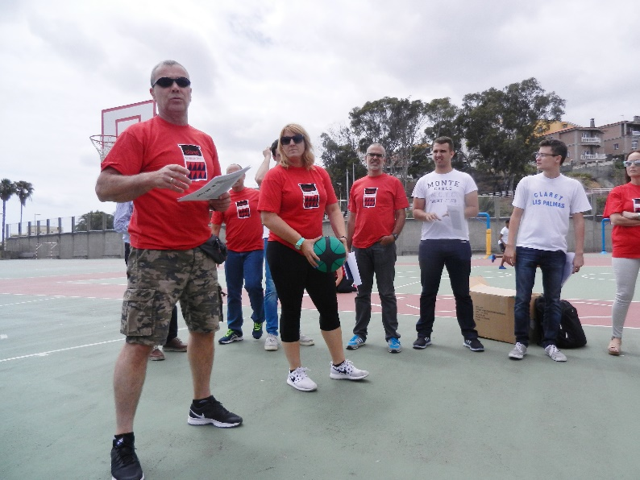 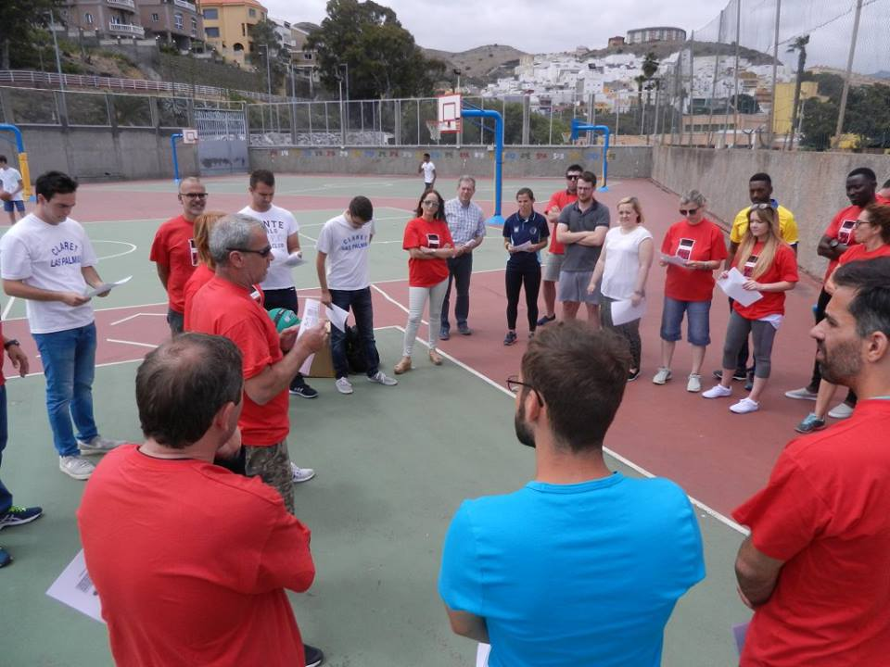

Vassilis explained that these styles give the pupils a chance for autonomous learning….which increases motivation. (We should encourage this).

Strategies promoting a climate of autonomy outlined included:

--Increase contact time

--Ask questions about what students want to do.

--Provide students time to work at their own pace

--Increase academic learning time

--Position of students – teachers.

--Justification of the activities

--Use of recognition

--Feedback

--Relationship with students.

These 9 strategies are what they propose will benefit learning.

Performance will be negatively impacted if:   
--teacher dominates

--Teacher gives the solution all the time.

--There is intense guiding

--Use of instructions that state obligation.

--Reminder of deadlines

--Enhancement of the compliance to the teachers’ instructions.

--Criticism of the student.

Evaluation then took place and it was time to break for lunch.

All of the project partners then went out to take part in the huge celebrations of Claret School around their ‘School Olympics’. This was very impressive celebration of coming together, of international engagement, of the Olympic ideals and of fellowship. Under the Canarian sun, we watched the processions, including the high profile placing of the flags of the PHWB partner countries as the procession went past.

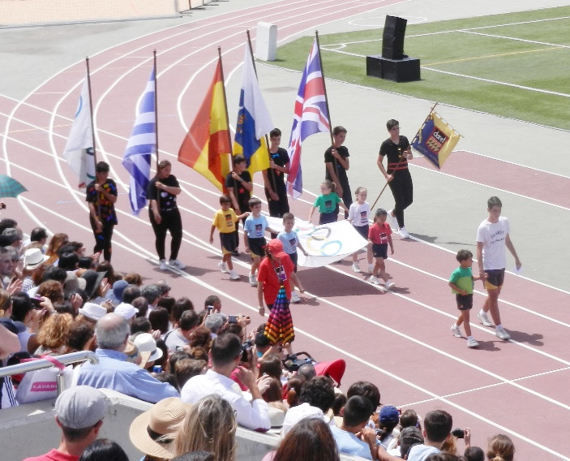 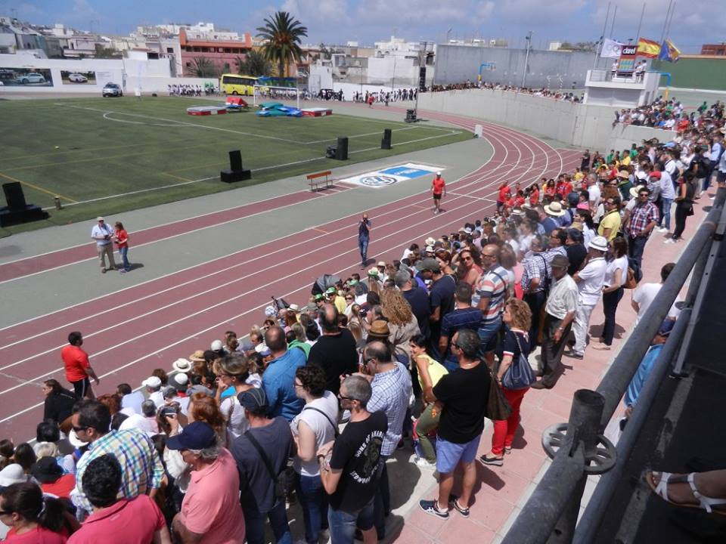

5.15pm After the ceremony, we returned to the School building. It was time for the Spanish partners to lead the training based on elements from Module 6. Gender & Disability & Cultural issues affecting Physical Education

Workshop leaders Antonio and Havier began by presenting information about a movement task.

Objectives….to appreciate the value of traditional games etc. as a way of reaching all pupils.

Taking part--promotes tolerance and respect, teaches team work, passes down history and traditions. Increases body confidence, promotes cultural expression & diversity. It’s an inclusive way to get pupils active without the ‘winners & losers’ aspect of many sports.

Activities were also undertaken with one or more of the group blindfolded to make people think about blindness and movement.

Everyone evaluated this module work also, before the long, but productive and varied training day ended.

**Saturday 17th June, 2017**

The venue for the next day of our PHWB Training Activity was Tafira campus of the University of Las Palmas.

10.15 We began the day with a recap of the previous day’s work and a look at the schedule to come.

10.25 Matt R (John Donne Academy) began to lead the UK partners presentation based on work in PHWB Module 2.

In pairs, participants considered, “Why do we teach PE?” Many answers were suggested: Building a foundation of skills/ to aid development/ to develop a love of exercise/ to develop a social culture for the school/ for fun.

After instruction on the task to come, participants then went out to the running field for practical tasks. Matt and Andrew (Alfred Salter Sch) led a task on moving and high fiving. We understood the progression this displayed and that they were suggesting that children with little experience of sport of physical training need in order to master tasks that can seem to others to be quite simple.

Dean and David (Club Pulse) then led a talk about teaching styles – implicit and explicit coaching… with high kicking and squatting then all in pairs showed the same styles of coaching around a task of their choosing which they then demonstrated for the class. e.g. Javelin throw described as a way of ‘stopping an elephant charge’…

Once the physical tasks were over, we returned to classroom for group discussions: what are the advantages and disadvantageous of the explicit style of teaching? There was great engagement of the teams as they reported on their discussions and considered which style might work better for various sports etc.

Vassiis mentioned that this ties in positively with what was taught for Module 3.

Andrew and Matt: Matt went over how his task for running was run.

Lesson 1: Competitive, exclusive elitist, objectives met by all? Focus purely on the physical.

Children could feel disenfranchised…the same person would always win.

Lesson 2: Clear objectives met/ inclusive / children setting their own challenge. Not only physical.

Discussion: how should PE look in our school -- it should be modelled by all staff and not ‘bought in’….should be fun, should be for everyone. Whole school approach. Teachers need to be more active / it should be fun stressed again.

Evaluation forms were again distributed to participants.

12.45 The Greek team then began to deliver training based on Module 4. (Behavioural change for healthy lives)

“We need to bring about change in lifestyle, is the message we have to share.”

The Greek side delivered some theory and then some practical tasks related to this. “Students must **like** PE lessons to want to change.” This work relates to modules 2 and 3 also.

Health Education model….

Behaviour change models -- Trans theoretical model/ AND 2 others were considered

Ideas were exchanged and we found that the room layout (less theatre style and with moveable chairs) worked better for today’s exchanges.

Vassilis B handed over to Vasilios P. to talk about life skills development.

He suggests teaching life skills through sports. Not only physical skills are beneficial.

Life skills are ones that help us succeed in our various environment. They help us deal with the demands of life. Behavioural, cognitive and inter and intra personal.

Group discussion: What life lessons do students learn from their participation in sports and in PE classes?

Suggested were: How to be a leader/ how to be a follower/ how to control emotions/ setting and achieving goals/ success requires work/ how to win / how to lose/ know your strengths and weaknesses / being healthy is important/ how to deal with stress/ self-responsibility / respect for all / together everyone achieves more/ Focus on what you can control.

Vasillios then showed photos of the university program where parents of young children bring their children to the University gym to learn and grow. He showed video of them playing games on the University field to learn problem solving etc.

How to teach life skills: Teach concept first/ provide examples for use in both sport and non-sport settings / apply and practice review and discuss success and failure

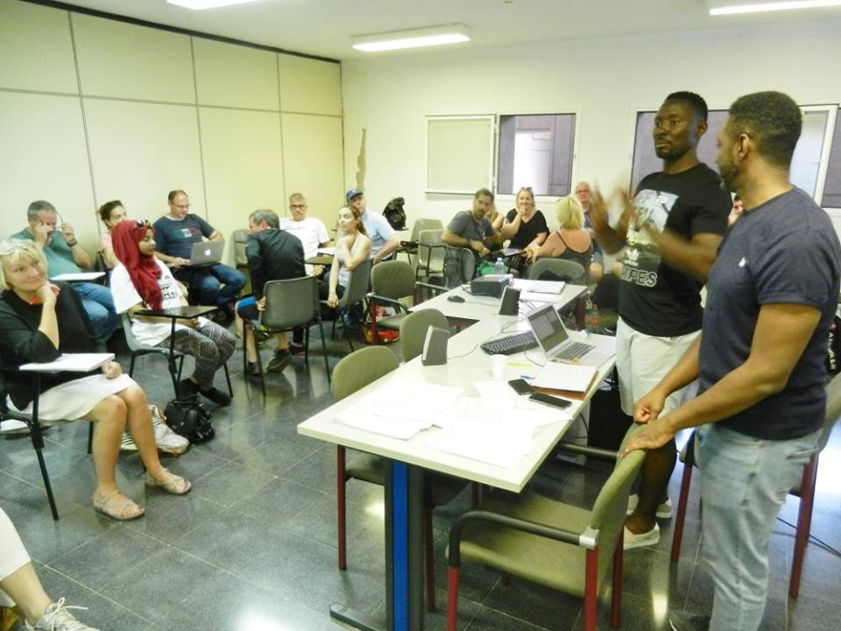 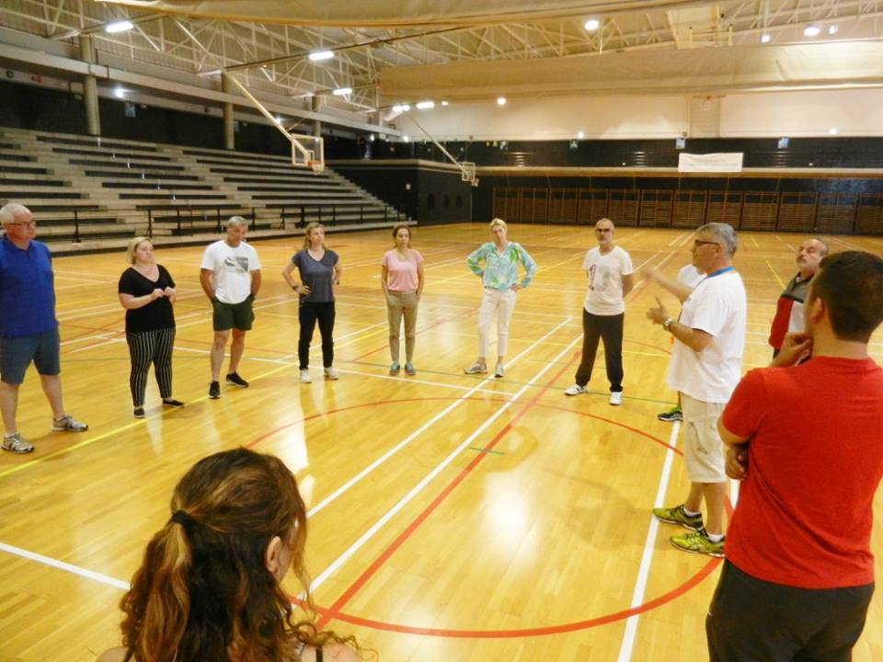

1.20 We then went to the sports auditorium to do a practical activity on the basketball courts…..teaching life skills as well as utilizing the basketball skills learned earlier.

In teams participants worked together to score points in a passing and shooting exercise. All got involved and enjoyed this activity.

3pm A fantastic lunch was served outdoors and enjoyed by everyone.

At 4.20, we then returned to the classroom for the final training delivery of the day. Module 5: Community participation and environmental tie in for health and well-being.

Jesus A (University of Las Palmas) outlined some social problems and needs. What we need is a process of change--greater social cohesion is possible. A national health system working hand in hand with positive social change is the ideal.

He presented the Precede/ Proceed model for positive change.

Health promotion in urban areas…..can start in schools. Create eco-friendly school gardens (helps the young respect the environment, know the links between horticulture and nutrition, reject junk food, and understand the connection between diet and health.)

Supplemental activities. Collect rainwater/ making information leaflets about nutrition, analyse produce used for lunch. Develop training activities with families. Involve the families and the communities. Physical activity outside of sport and pe. E.g. hiking….. General mobility.

2/ Educating for Environmental care—Water and air quality, noise, smells, lighting.

Raise pupils and family awareness of the use of public transport or walking to school.

This proved to be a good module….giving practical tips for teachers.

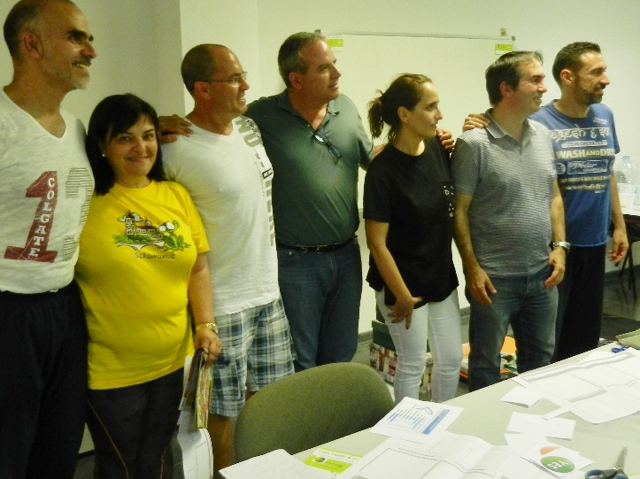 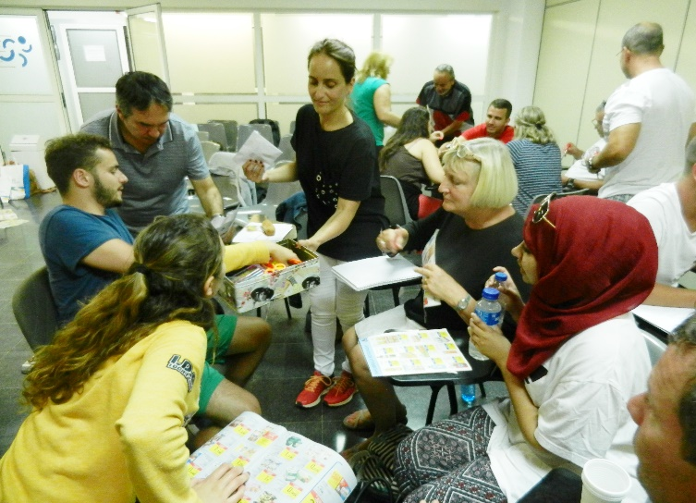

To do all this educating well….schools and teachers must be aware of the living conditions of the pupils at home. Safety, overcrowding, poor housing conditions etc. are often the norm.

Theoretical Justification—Nature deficit disorder.

There will be a reduction of violent attitudes, psychological well-being etc. as a result of spending time in nature.

4.50. Jesus handed over to Ulises and the Spanish school staff.

They talked of activities they have done with their pupils at Marpequena School. These were numerous and enthusiastically demonstrated.

This was followed by a Group task. Coordinator and other roles decided etc. Pictures from magazines cut out and used to illustrate where food comes from, when it’s in season etc. This could be a useful teaching activty for younger pupils.

Once the Spanish had finished their delivery of activities related to this module, it was again time to evaluate before a short break.

At 6.20 Evelyn (UK) opened the information gathering session.

She asked for feedback to help the further dissemination of the PHWB project and its related training going forward. Do the modules work as a course? Are they in the right order? Is the balance of activities right? Is the amount of content we’ve shared in the last few days enough to fill a week long Erasmus+ KEY ACTION 1 course based on our project outcomes….or would more content be needed?

First participants considered these questions alone. Then they discussed them with the person beside them. Them they reported back to the wider group.

**Comments:** There’s a good balance between active and passive tasks. Nick (UK) didn’t think the module order was quite right. I would have finished with the 1st Greek module on day 1. Good module 4 from Greece.

Janine (UK) learned something…e.g. incorporating life skills into PE lessons.

Diego (UK) I’ve been impressed and will use the strategies shown in my classroom. E.g. Maths and English will incorporate sport…we can play games while learning them.

Nick (UK)….I would use some real children modelling the methods discussed.

Stefania (GR) …..I think the combination between theory and practice was good. Marpequena school, though, needed more time. Their part was too rushed.

Phil (UK) with some activities could have been expanded more. He liked the practical sports ones. He liked making links with sports and subjects. Lots more materials online Evelyn says if folk want more.

Naz (UK)….course format works well. But clearer instructions needed for many of the practical tasks games. Vespina (GR) ….interesting overall…but the activities need cohesion. Because I’m not a PE teacher, I wasn’ t sure if it was for me. I can use some bits….but there was not enough focus for teachers like me.

Samuel (ES)… more clear instruction needed. We were sometimes lost. More time for the practice as well. We wasted time just moving to the new location of various activities in some cases.

Theo (GR): I feel lucky that I spent this time with you. I agreed with the beliefs the people here of what a teacher should be. I agree with the theme of the work…..happiness and balance are key. It was not a new idea for me….but there were many new things I took from all of you. I think we can use play and games to reach our goals.

Lorenzo (ES)…..I missed at the end of each session that there was no time to discuss.

Nick (UK) I think there needs to be a facilitator to link all sections together. To make it flow.

Chris (UK) ….diff cultures affect what was thought of different modules. We agree that there was little ‘joining up’ between the presentations from the different modules and this can be fixed.

And….. it DOES seem that we don’t need any more content to fill a week long course. We can use any additional time available during a longer course for extra time for reflection. We’d have a slower pace…and earlier finishes which would work well—but both our amount and variety of content feels good.

Vassilis B then handed out evaluation forms for completion by all so that data could be collected as at all of the previous joint meetings where participants have been surveyed using the forms.

There was then time to discuss other aspects of the project that all 3 countries have been working on and will continue to work on until the end of the contract period.

**Multiplier events**…..400 teachers in Greece took part in 9 events during the last 2 years.

UK will have last event in Sheffield. 17th august 2017. 48 participants are expected and this follow an earlier successful Multiplier event this year, held at Goldsmiths University.

Spain…..carried out the project with students primarily. They have incorporated it into their Teacher Training curriculum. Teacher trainees have to use the project Facebook page. Etc. in their classes. University staff have actively promoted PHWB, giving presentations about the project to many international partners at conferences including in Lanzarote and Salamanca.

**Publications**…..2 publications from the Spanish team written/ one from the Greek…and 3 left to write.

GR needs data from ES. It’s coming. The UK schools have supplied theirs.

ES had wanted disability surveys from the families of our school pupils in order to collect data for other research but decided …. Its no longer required. Agirios (GR) reported on research and congresses the Greek team have contributed to.

The coordinator explained that all of this outstanding work needs to be reported on and would benefit the project web site if teams can send links to their publications & other outputs. Especially photos are valuable so the EU and others can see what has been done and achieved.

What other activities can happen going forward?

Send a list of extra activities that have resulted from our links. Eg. job shadows, Erasmus student placements, student exchanges, Babis researching linking

Finances were then discussed. These have been time consuming to manage and problematic – because some of the grant is only paid well after the final reporting (which is not due until end of October) and because the banking transfer system seems to often fail without anyone being notified.

Monies for translation of modules and for dissemination events will only be paid AFTER the second grant instalment is received from the British Council. This might not be until early 2018.

Toni A (ES) then made final comments to close the meeting. Evelyn (UK) responded and the coordinator thanked everyone, but especially the Spanish for hosting 2 of the Joint Meetings and for their excellent hospitality and planning. Greece leaders thanked everyone too and this day’s work drew to a close.

**Sunday 18th June, 2017**

The teams were collected at 10.00am and driven south to the historical town of Agüimes for their last formal activities of this Joint Meeting. The coach ride and the stop for coffee allowed participants to discuss the next activities of the project in their various institutions and to discuss potential for future collaboration together.

College students then led the PHWB team on a historical recreation tour of the town, teaching us about the various people, culture and developments in Agüimes during the past in an engaging way. We were able to try traditional foods at the various stops on the walking tour and discuss the history of the Island. The great effort that had gone into presenting all of this for us was much appreciated.

Later at the shared lunch together, we were able to thank the organisers for the effort that went into this, as well as to make speeches brining the last Joint Meeting of the PHWB project to an end. This project has had a profound effect on many of those take part and been a hugely positive experience. Thank you to everyone who has contributed so well.





