Pupil health and wellbeing project – Spring update!
Since our visit to Gran Canaria we have continued taking Year 6 to Goldsmith's Club Pulse Gym. The children have thoroughly enjoyed participating in the various activities there and we have noticed a real improvement in the children overall fitness and attitude towards staying healthy. After the success of the year 6 children attending, we have just started Year 5 along the same regime.
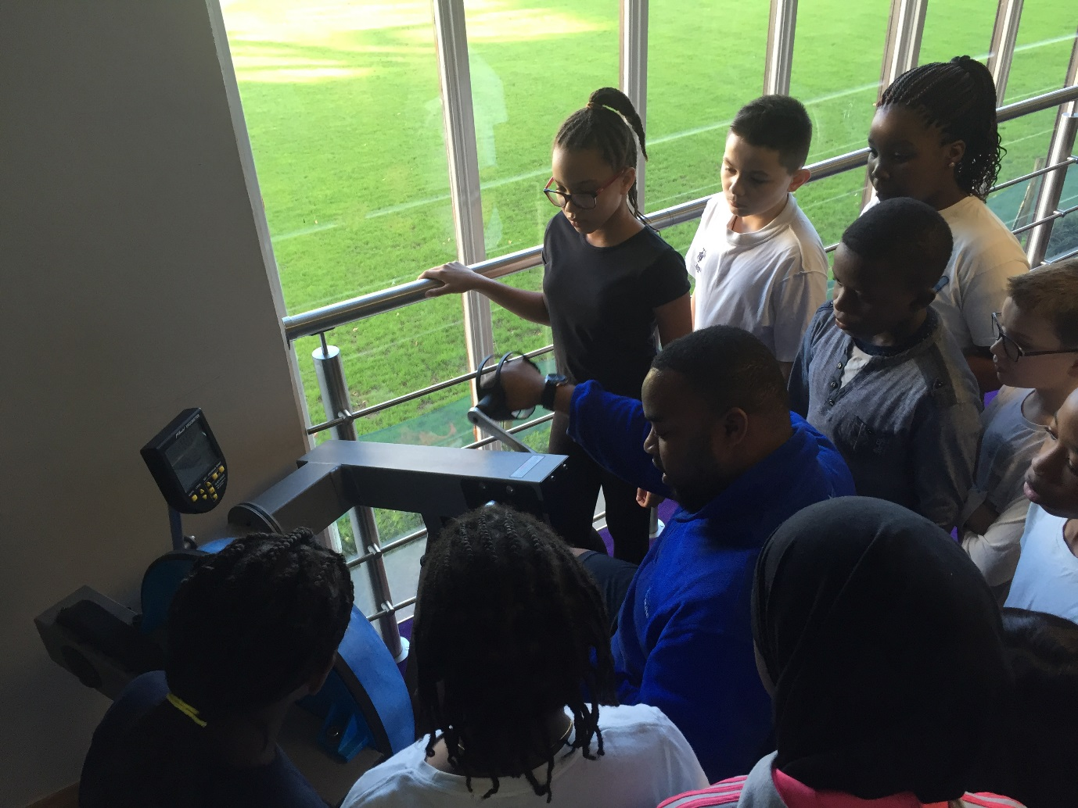
We were also able to get the parents of John Donne involved on Mother’s Day and they attended with the children from Year 6.
We have invited David, Dean and the staff of Goldsmith's Club Pulse Gym to run a station at our Sports Day event in June. This will be one activity within the carousel of activities planned when every child will visit during the day.
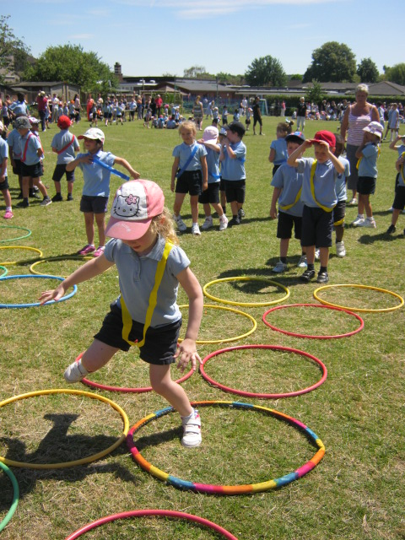
We have ‘bikeability’ training for the children of year 6 after half term where an outside agency come in and teach 30 children how to use a bike safely on the streets. With this we have ordered 10 bikes for the school to use with children of the school to help them with learning to ride/use a bike safely.

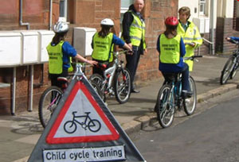
We have encouraged staff to take part in a mixed football team and have played a few games against local schools.

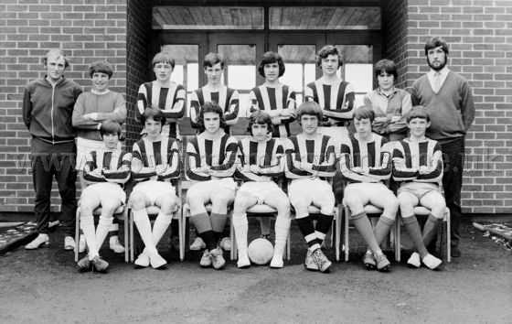
On Thursday 16th June 2pm, we plan to host all school children in our sports hall to watch the European Championship game between England and Wales. This offers the opportunity for children and staff to get behind our nation whilst immersing ourselves in a European competition.

We have continued to offer a wide range of healthy meals for both children and staff and change this three-week menu every term.
​During school council meetings, pupils have been discussing development of the playground and the different opportunities for children.
We have ordered and been using 36 yoga mats for lessons with Year 2 and Year 5 children. The children have been loving this as have the teachers.
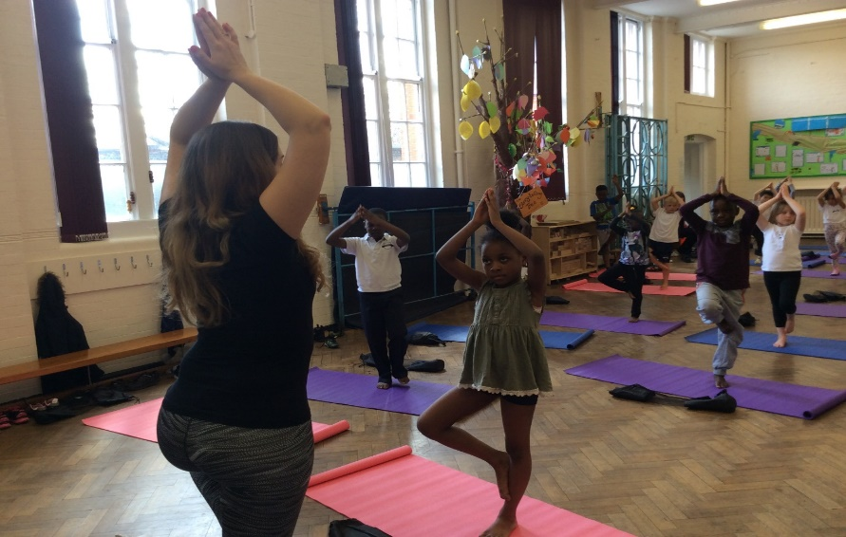
We hold Free Zumba sessions for parents on a Monday morning…….
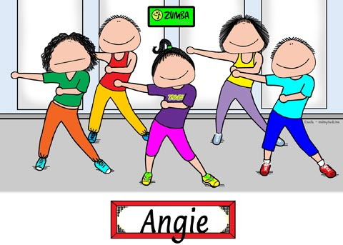
We are planning a team- building Inset with another local school in June (London Treasure Hunt)

Taken part in a variety of sporting events both competitive and non-competitive. Here are our cricket team having won a tournament at the Oval Cricket Ground.
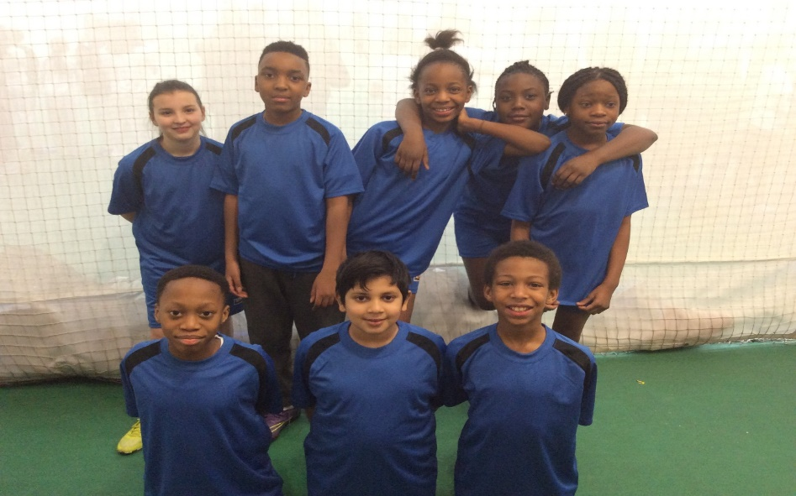

All school involved in recording a CD with enjoyable songs
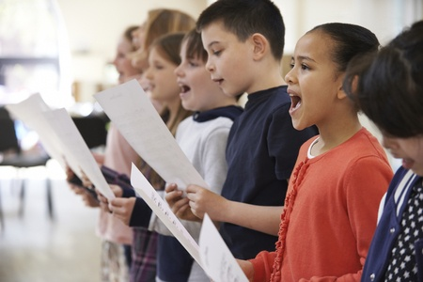
Pupil and adult choir to sing at a local music event
Weekly learning and fun sessions for parents and children after school
Intensive support for several families in serious financial difficulties
Food bank support for families in need of food
Free Holiday Club provision for pupils who are having difficulties at home
And finally…….fresh coffee available for all staff across the school
